

**Evaluation of the Effectiveness of HIV Assistance**

**DNSC 6217 - Business Analytics Practicum**

**Team Members**

Daniel Chen, Kelly Berdelle, Aida Roxas

**Table of Contents**

* 1. Abstract………………………………………………………………………………..3
  2. Executive Summary…………………………………………………………………...4
  3. Introduction……………………………………………………………………………5
     1. Highlights of the AIDS Epidemic……………………………………………..5
     2. Task……………………………………………………………………………6
     3. Motivation for the Project……………………………………………………..7
  4. Background……………………………………………………………………………8
  5. Data Preparation……………………………………………………………………...11
  6. Analytical Hierarchy Process………………………………………………………...12
  7. Data Envelopment Analysis………………………………………………………….15
  8. Comparison of AHP and DEA Results……………………………………………….21
  9. Linear Regression…………………………………………………………………….23
  10. Hypothesis Testing…………………………………………………………………...27
  11. Conclusion…………………………………………………………………………...29
  12. References……………………………………………………………………………30
  13. Appendix……………………………………………………………………………..32
      + 1. **Abstract**

HIV relief funding has been critical in the fight against the disease; therefore, the efficient use of these funds is of great concern. This study used Analytic Hierarchy Process (AHP) and Data Envelopment Analysis (DEA) to develop an efficient frontier of sub-Saharan African countries that receive this funding. Additionally, this study used regression analysis and hypothesis testing to attempt to identify possible contributing socioeconomic factors that may explain why certain countries perform better than others. In analyzing sub-Saharan countries, our results show that using AHP, the top performing countries were South Africa, Namibia, Tanzania, Uganda, Swaziland, Botswana, and Mozambique. Using DEA, the top performing countries were Cameroon, South Africa, Mozambique, Malawi, and Zimbabwe. The linear regression analysis shows that an increase in net primary school enrollment ratio and a decrease in teenage fertility rate may increase a country’s performance in our efficient frontiers.

* + - 1. **Executive Summary**

In this comparative study between sub-Saharan African countries, the goal was to identify top performing countries in relation to their efficiency in using HIV assistance funding to reduce the AIDS epidemic. In order to do this, we utilized Analytic Hierarchy Process (AHP) and Data Envelopment Analysis (DEA). AHP is an optimization method in which subject-matter expertise is used to identify a priority vector to weight output variables, and countries are compared using their weighted priorities. DEA, on the other hand, is a measure of the relative efficiencies of countries given their outputs and inputs. The study identified South Africa, Namibia, Tanzania, Uganda, Swaziland, Botswana, and Mozambique as top-performing countries using AHP. Likewise, Cameroon, South Africa, Mozambique, Malawi, and Zimbabwe are the top-performing countries identified by DEA. Once the ranking of the countries was established, we investigated further socioeconomic factors that may have a possible impact on results. Using linear regression analysis, we found that an increase in net primary school enrollment ratio and a decrease in teenage fertility rate may increase a country’s performance. Therefore, this study recommends that countries that desire to improve efficiency in use of HIV relief funding may need to work to improve factors that inhibit attendance in primary schools and additionally work to educate teens about safe sex practices. Due to gaps in our data collection and inconsistent estimates provided by different sources, this study only claims to identify preliminary results and all results would require further confirmation if given a more complete set of data.

* + - 1. **Introduction**

1. *Highlights of the AIDS epidemic*

AIDS, or Acquired Immune Deficiency Syndrome, is a serious condition that weakens the body’s immune system and leaves it unable to fight off illness. AIDS is the last stage in a progression of diseases resulting from a viral infection known as the Human Immunodeficiency Virus (HIV or AIDS virus). Symptoms of the disease include severe infections, cancers, and debilitating illnesses resulting in severe weight loss and diseases affecting the brain and central nervous system.

There is no cure for HIV infection or AIDS, nor is there a vaccine to prevent HIV infection. However, new medications not only can slow the progression of the infection, but can also markedly suppress the virus, thereby restoring the body’s immune function and permitting many HIV-infected individuals to lead a normal life.

The origin of the Human Immunodeficiency Virus (HIV) has been a subject of scientific research and debate since the virus was identified in the 1980s. While it is widely believed that HIV crossed species from chimpanzees to humans, up until the 1980s, we do not know how many people were infected with HIV or developed AIDS. Now, 2016 fact sheet from UNAIDS show a clearer picture of the worldwide issue at hand:

* 36.7 million people are living with HIV, including:
  + - 34.5 million adults
    - 17.8 million women (15+ years)
    - 2.1 million children (<15 years)
* 1.8 million people became newly infected in 2016
* 1 million people died from AIDS-related illnesses in 2016

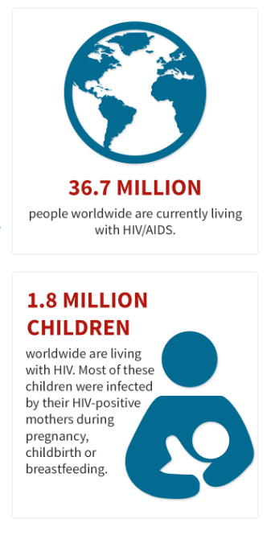

For 2015, UNAIDS reports the numbers as shown below.

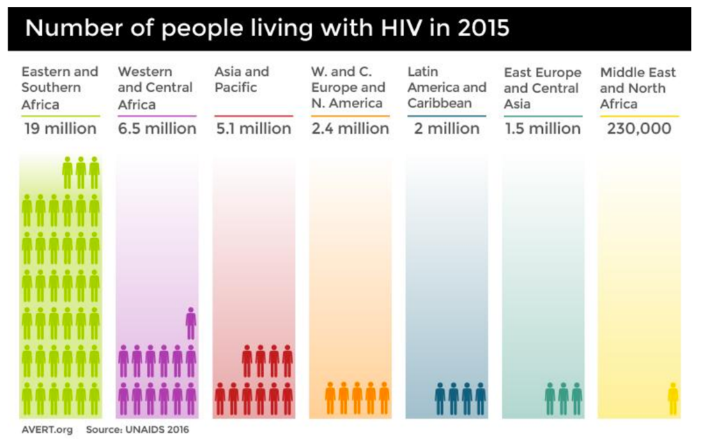

These figures demonstrate the need for more knowledge of the disease and how to best combat it.

1. *Task*

Economist Harry Markowitz first coined the term "efficient frontier" in 1952. According to Markowitz, for every point on the efficient frontier, there is at least one portfolio that can be constructed from all available investments that has the expected risk and return corresponding to that point.

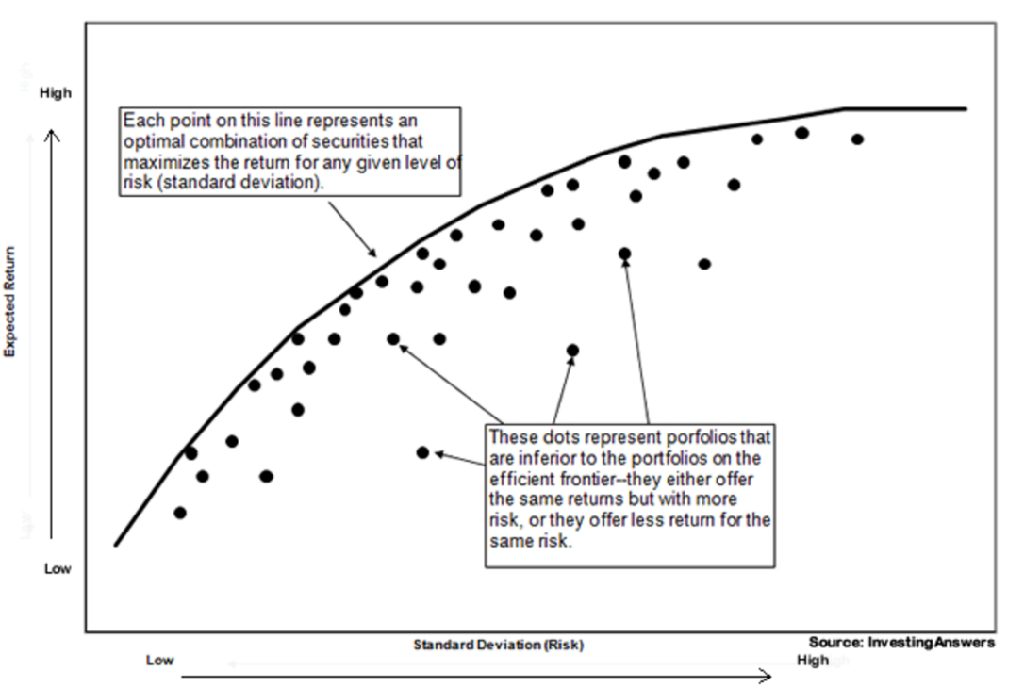

This study aims to leverage on Markowitz’s concept of the efficient frontier in hopes to identify the optimal use of HIV/AIDS funding contributions.

1. *Motivation for the Project*

The goal of the project is to analyze how the countries of sub-Saharan Africa utilize monetary resources to combat the HIV epidemic. The challenge is to determine the effectiveness of programs using publicly available datasets and develop an efficient frontier of the countries receiving AIDS relief funding. More specifically, we intend to examine the countries’ variations in the efficiency with which pooled funds are used to reduce new HIV infections so that we can establish benchmarks. We employed the optimization techniques of Analytic Hierarchical Process (AHP) and Data Envelopment Analysis (DEA) for this study.

* + - 1. **Background**

The U.S. President's Emergency Plan for AIDS Relief (PEPFAR) is the U.S. Government’s initiative to help save the lives of those suffering from HIV/AIDS around the world. This historic commitment is the largest by any nation to combat a single disease internationally.

PEPFAR was launched in 2003 by President George W. Bush, and, since its inception, has received strong bipartisan support in Congress and through subsequent administrations. The U.S. government committed, along with the generous support of the people, a total PEPFAR funding amount of more than $70 billion from 2004 to 2017, as reported in July 2016. The United States is unquestionably the world’s leader in responding to the global HIV/AIDS crisis. It is the iconic brand of U.S. government engagement in health, development, security and diplomacy, unparalleled in its capacity to deliver clear, measurable, and transformative results and impact.

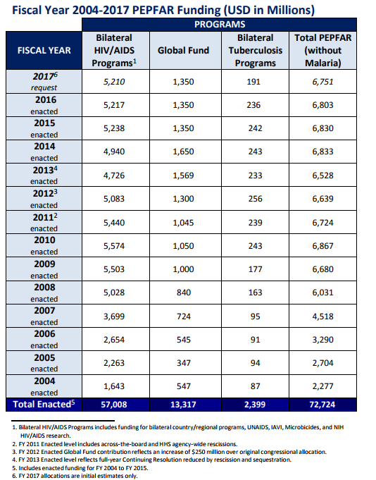

When PEPFAR was launched in 2003, the word “emergency” in its name understated the problem. The world was facing a crisis, particularly in Africa, where people were dying by the thousands because the antiretroviral therapy (ART), which was being used in the United States, was not available in Africa. At the time, it was estimated that nearly one-third of the population of some sub-Saharan countries were infected with the virus and over 20 million of their mothers, fathers, teachers, doctors, nurses and children had died. AIDS had already wiped out an entire generation, producing 14 million orphans and vulnerable children. Moreover, much of Africa did not have the infrastructure to prevent, treat, and care for people even if ART was available.

With prevention and treatment becoming a rallying cry, hospitals and clinics were built and renovated, doctors and nurses were trained, and people were urged to get on and stay on treatment. Men and women were given condoms, and programs were launched to encourage their use. Pregnant women were educated about preventing HIV transmission to their unborn children by actively receiving treatment. Babies were born HIV-free and children who were infected were treated. Increasingly, countries were driving their own programs and governments could carry out their HIV strategies, which had been developed but lacked the resources for implementation. Prevention, treatment, and care became a shared responsibility between the country and its partners, which included the U.S. and other donor nations, civil society, faith-based organizations, the private sector, foundations, multilateral organizations and people living with HIV/AIDS.

Implementation came in phases. Phase I of PEPFAR focused on building an Emergency Response; Phase II, as continued under the Obama Administration, emphasized sustainability. PEPFAR established Partnership Frameworks. Together, joint strategic roadmaps developed, and were agreed to and signed by the U.S. and partner governments, promoting mutual accountability and sustainability. PEPFAR signed 22 Partnership Frameworks from 2009 through 2012, launching a new era of collaborative planning and health systems strengthening activities with our partner governments. An emphasis was also placed on increasing the impact of PEPFAR’s investments by scaling up access to ART, preventing mother-to-child transmission (PMTCT) and voluntary medical male circumcision (VMMC). This led to the landmark announcement in June 2013 by Secretary of State John Kerry that one million babies had been born HIV-free thanks to PEPFAR support.

Now, PEPFAR is heading into what may be its most challenging, but exciting, phase yet—Phase III. Phase III focuses on sustainable control of the epidemic. The Joint United Nations Program on HIV/AIDS’ (UNAIDS) set the ambitious 90-90-90 global goal: 90 percent of people with HIV diagnosed, 90 percent of those individuals are receiving ART, and 90 percent of those individuals have viral suppression by 2020.

In just eleven years, PEPFAR has moved from an emergency program to one squarely focused on controlling the epidemic.

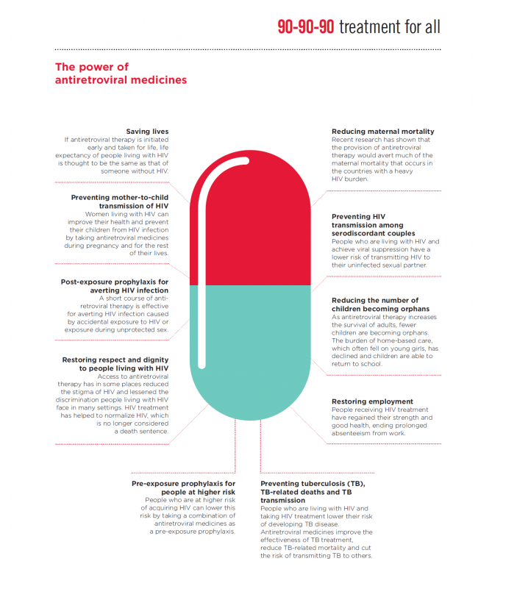

* + - 1. **Data Preparation**

We collected data from readily available sources that included UNAIDS, Index Mundi, Science Direct, The World Bank, CIA World Fact Book, IAPAC, the World Health Organization, and Avert. There were significant gaps in the data collected, and we had to consider data integrity as a critical element for the continuation of our study. Upon consultation with our client, we identified sub-Saharan countries which had the most complete data available. The sub-Saharan countries we were able to consider for this project were Ghana, Nigeria, Cameroon, Democratic Republic of the Congo, Angola, Zambia, Botswana, Namibia, Lesotho, South Africa, South Sudan, Ethiopia, Uganda, Kenya, Rwanda, Burundi, Tanzania, Malawi, Zimbabwe, Mozambique, and Swaziland.

During data collection, we found that the available data spanned for several years. Due to a lag in demonstrable outputs from funding sources, we ensured that all input variables predated the output variables. We controlled for our input variable to be from 2006 – 2013 and the output variables from 2009 – 2014.

Our analysis used a single input variable. We used the aggregated funding amount as reported by UNAIDS and divided this figure by the total number of HIV positive adults. While many sources offered individual measurements for PEPFAR Funding, Domestic Funding, and The Global Fund, we found inconsistent estimates and gaps in reporting. Therefore, for consistency and data integrity, we selected the single output variable of total (or aggregated) funding per HIV positive adult. For the output variables, we chose “Percentage Decline in New HIV Infections Among Children,” “Percentage of Infants Born to Women Living with HIV Receiving a Virological Test Within Two Months,” “Percentage of Pregnant Women Living with HIV Receiving Antiretroviral Therapy,” “Percentage of Children Living with HIV Receiving Antiretroviral Therapy,” and “Percentage of Children Exposed to HIV Receiving Co-trimaxozole.”

* + - 1. **Analytical Hierarchy Process (AHP)**

Analytic Hierarchy Process (AHP) is a decision-making method that was originally developed by Prof. Thomas L. Saaty. It is a method to derive ratio scales from paired comparisons. The input can be obtained from actual measurement such as price, weight etc., or from subjective opinion such as satisfaction feelings and preference. AHP allows some small inconsistency in judgment due to human error. Because we wanted to impose the relative weights, or importance, to the output variables, we employed AHP.

Additionally, AHP is to obtain a “priority score” of each sub-Saharan African country based on *only* its performance in HIV reduction. In other words, there is no input variable, i.e. “Total Funding per HIV Positive Adult”, to consider. The countries are compared solely on the output variables, which are the same five HIV reduction measures discussed in Section E. AHP’s priority scores tell us how “effectively” the countries are in meeting the HIV reduction targets; conversely, DEA’s efficiency scores would tell us how “efficiently” the countries perform while meeting the HIV reduction targets.

AHP formulation generally consists of 3 steps: (1) Criteria Comparison Matrix (CCM); (2) Check for Consistency; (3) Synthesis of Priority Vector and Scores. First, we created a 2x2 reciprocal matrix for the five HIV reduction criteria. With the help of an AIDS subject-matter expert, we then filled in the matrix with subjective relative-importance ratings (with integer values from 1 to 9) for each criterion. For example, we determined “Percentage Decline in New HIV Infections among Children (2009-2014)” to be 9 times more important than “Percentage of Infants Born to Women Living with HIV Receiving a Virological Test within 2 Months of Life (2014)”. The populated CCM was then normalized (each entry was divided by the column sum) and the geometric mean of each criterion was calculated. See Exhibit 1.

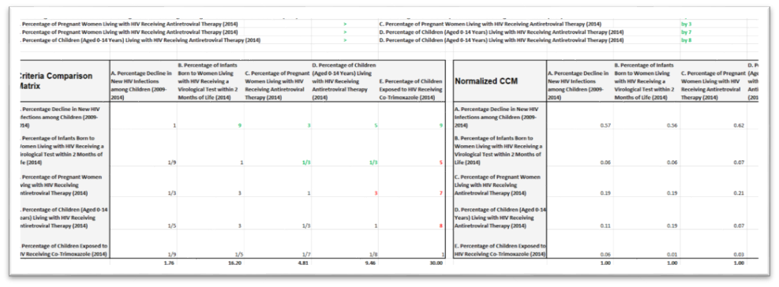



Exhibit : AHP Criteria Comparison Matrix

For the next step, we wanted to make sure that the ratings were consistent. In R, we accomplished this step with one line of code by invoking the built-in function ConsistencyRatio() in the FuzzyAHP library (Appendix 1). R returned the following statement: *“Consistency ratio is: 0.0919635051659509. The pairwise comparison matrix is consistent for calculations.”* In Excel, the step includes calculating the consistency measures Consistency Index (CI) and Consistency Ratio (CR). To derive the consistency measures, we used the matrix multiplication function “=MMULT()” involving the normalized CCM and geometric means from the first step. We then approximated the CI, which is defined as “the average of the consistency measures minus the number of criteria divided by the number of criteria minus 1”. The CI came out to be 0.10. Finally, we calculated the CR by dividing the CI by the Random Consistency Index (RI), which is a published index. For a matrix that has 5 criteria (n = 5), the RI is 1.12. Since CR = CI / RI, we arrived at a CR of 0.09. The general rule is that if the CR is smaller than or equal to 10%, the CCM is consistent. Therefore, consistency is satisfied for our CCM. See Exhibit 2.

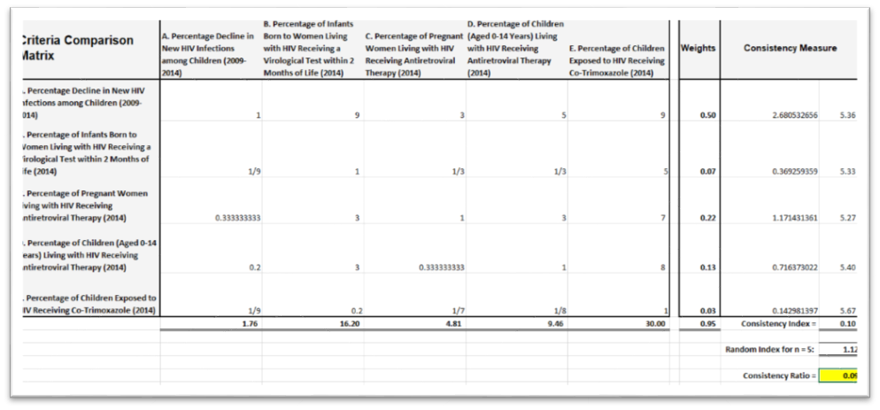

Exhibit : AHP Consistency Check

For the final step, we built another pairwise matrix containing the values for the five HIV reduction criteria for all the countries. We then applied the Priority Vector to this pairwise matrix to generate the scores. The computation of the Priority Vector is a little complicated, involving the eigenvector of the CCM. Fortunately, in R, it can be done simply through the function CalculateWeights(), which returned the values of 0.5268, 0.0729, 0.2340, 0.1398, and 0.0266 (Appendix 1). Scaled differently, they become 20, 3, 9, 5, and 1. We then used the Excel matrix multiplication function “=MMULT()” to obtain the final score for each country. See Exhibit 2.

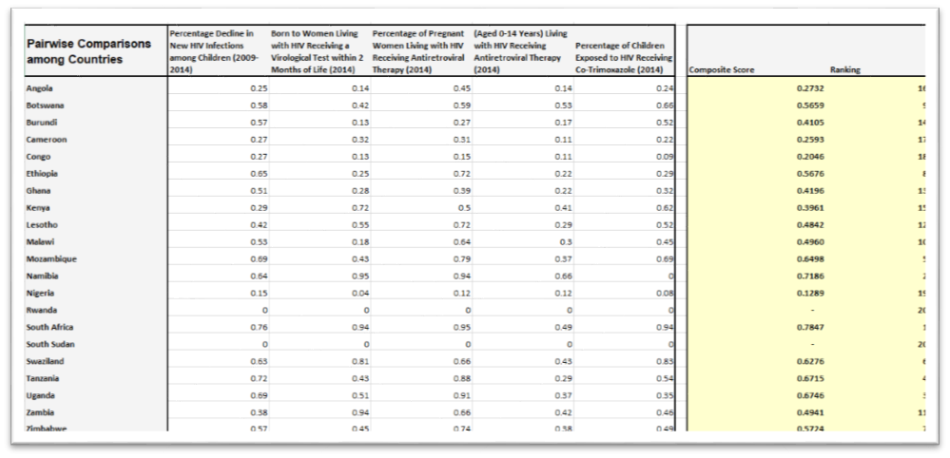

Exhibit : AHP Priority Scores

The results of our AHP showed that South Africa, Namibia, Uganda, Tanzania, Mozambique, and Swaziland have relatively high scores while Angola, Cameroon, Congo, and Nigeria have relatively low scores. Such results are in line with the expectation of our AIDS subject-matter expert. The high-scoring countries all had large declines in pediatric HIV infections―South Africa: 76%; Namibia: 64%; Uganda: 69%; Tanzania: 72%; Mozambique: 69%; and Swaziland: 63%. In contrast, the declines in pediatric HIV infections for Angola, Cameroon, Congo, and Nigeria are 25%, 27%, 27%, and 15% respectively. Since “Percentage Decline in New HIV Infections among Children” is the most weighted criterion by far (20 times higher than the criterion “Percentage of Children Exposed to HIV Receiving Co-Trimoxazole”), the country that performs well per this criterion should receive a high AHP score.

* + - 1. **Data Envelopment Analysis (DEA)**

DEA is an operations research technique that is often used for benchmarking purposes. It measures relative productivity, i.e. productivity relative to others in the dataset rather than some theoretical maximum, and involves different inputs and outputs. In our case, we wanted to gauge the relative efficiency of each sub-Saharan African country by using the “one” input (the aggregate of PEPFAR, Global Fund, all other multilateral and bilateral funds, domestic public funds, and domestic private funds, divided by the UNAIDS estimated number of adults aged 15+ living with HIV) to achieve the “five” outputs (the five HIV reduction measures). Moreover, we wanted to obtain the relative efficiency for each “pairwise” set of input (one) and output (one), as well as the relative efficiency for the “entire” set of input (one) and outputs (five). Therefore, 6 separate DEA models were run to complete our study.

Each run of DEA is a simplex linear programming procedure, where the efficiency is the sum of weighted outputs divided by the sum of weighted inputs. The objective is to maximize the efficiency by changing the set of weights for the outputs. The procedure is subject to the following constraints: (1) All the weights must be greater than or equal to 0; (2) the difference between weighted output and weighted input must be less than or equal to 0; and (3) the denominator, or the sum of weighted inputs, is set to 1. The entire setup can be summarized in the following notation:

max ∑ ui yi

subject to

ui >= 0, ∀i = 1, m

vj >= 0, ∀i = 1, s

-∑ vj xj + ∑ ui yi <= 0

∑ vj xj = 1

We conducted each run of DEA first via Excel Solver and then separately in R for validation purposes. See Exhibit 4 below for a visual of the setup in Excel. See Appendix 2 for the written R program.

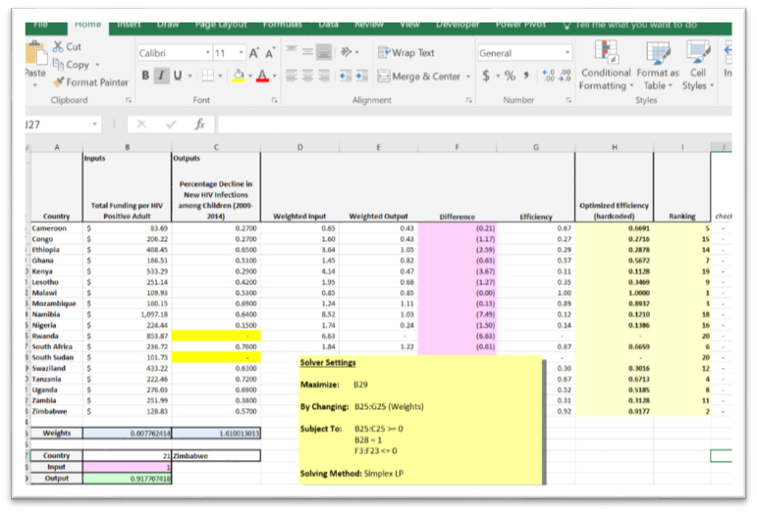

Exhibit : DEA Modeling in Excel

Each run of DEA produced efficiency scores that were then plotted onto a scatterplot. From there, an efficient frontier was formed. For a single-input and single-output DEA, there are two types of efficient frontiers: Constant-Return-to-Scale (CRS) and Variable-Returns-to-Scale (VRS). A CRS frontier reflects the fact that output will change by the same proportion as inputs are changed (e.g. a doubling of all inputs will double output). It is a line segment that extends from origin to the country with the highest efficiency score. It “envelops” all other points because it has the maximum slope and efficiency. A VRS frontier reflects the fact that production technology may exhibit increasing, constant, or decreasing returns to scale. It is a line segment that connects the countries on the upper left edge of the scatterplot, which are ranked at the top of efficiency. See Exhibit 5 through Exhibit 10 for visual displays of the frontiers.

Our first pairwise DEA analysis examines the duality relation between the input variable “Total Funding per HIV Positive Adult” and output variable “Percentage Decline in New HIV Infections among Children (2009-2014)”. Again, “Total Funding per HIV Positive Adult” is the aggregate of domestic private and public funding and various international funding sources divided by the estimated number of adults aged 15+ living with HIV. “Percentage Decline in New HIV Infections among Children” is probably the most telling measure of the success of AIDS relief because mother-to-child transmission is the most common means of HIV infection. It is the most important metric that UNAIDS and US Government use to gauge the progress in combating the HIV epidemic.

Per the latest Global Plan Progress Report, since 2009, South Africa has made one of the greatest progresses in reducing new pediatric infections and it has done so by 76%. It is followed by Tanzania (72%), Uganda and Mozambique (69% each), Ethiopia (65%), Namibia (64%) and Swaziland (63%). These are the same countries that scored high in our AHP analysis. Now, the question is – did they demonstrate efficient uses of funding resources while reducing pediatric infections?

Our DEA analysis revealed that most of these countries indeed demonstrated fairly good uses of funding resources while reducing pediatric infections. One exception is Namibia, which utilized a total funding amount per HIV positive adult of $1,097 to generate 64% reduction in new pediatric infections. South Africa, in comparison, utilized a total funding amount per HIV positive adult of $237 to generate 76% reduction in new pediatric infections. The best performing country, per our DEA result, is Malawi, which utilized a total funding amount per HIV positive adult of $110 to generate 53% reduction in new pediatric infections. See Exhibit 5.

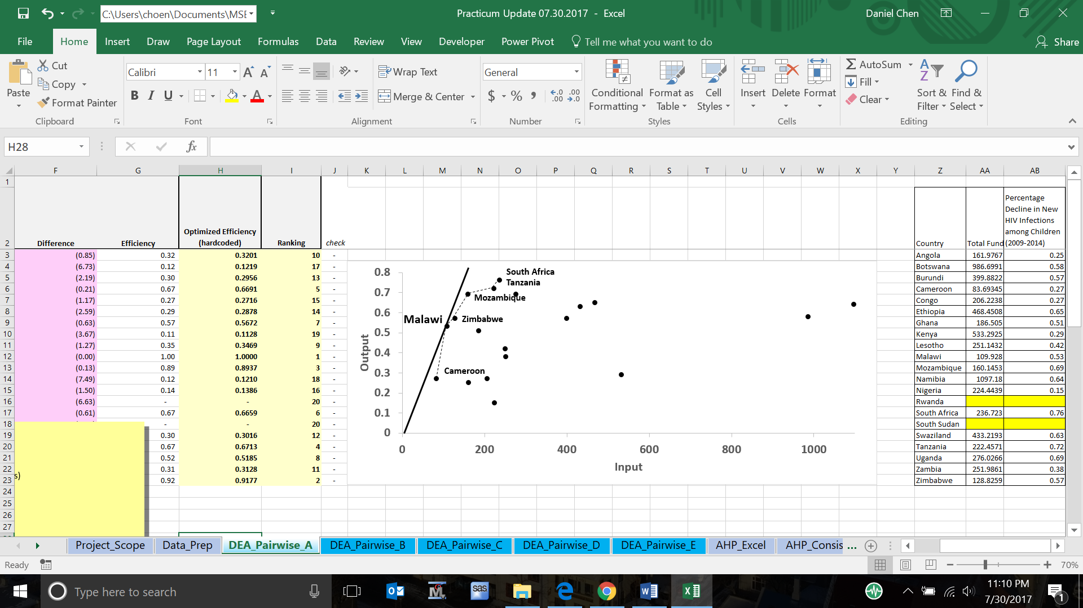

Exhibit : DEA Efficient Frontier: Percentage Decline in New HIV Infections among Children (2009-2014)

Our second pairwise DEA analysis includes the input “Total Funding per HIV Positive Adult” and output “Percentage of Infants Born to Women Living with HIV Receiving a Virological Test within 2 Months of Life (2014)”. Virological testing is needed for early infants, who still carry maternal antibodies. Our DEA model identified South Africa as the benchmark, with 94% of its infants born to HIV-positive women receiving virological tests within two months of life. See Exhibit 6.

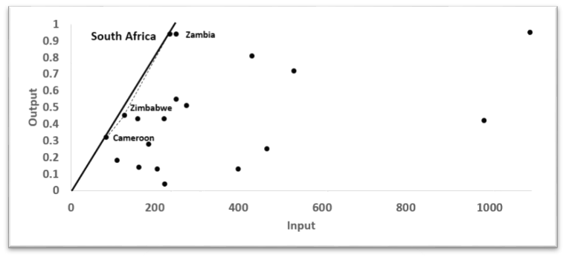

Exhibit : DEA Efficient Frontier: Percentage of Infants Born to Women Living with HIV Receiving a Virological Test within 2 Months of Life (2014)

Our third pairwise DEA analysis includes the input “Total Funding per HIV Positive Adult” and output “Percentage of Pregnant Women Living with HIV Receiving Antiretroviral Therapy (2014)”. Botswana, Mozambique, Namibia, South Africa, Swaziland, Uganda, and Tanzania all had 90% or more pregnant HIV-infected women receiving antiretroviral therapyin 2014. However, from an efficiency perspective, Malawi is the benchmark. It achieved 64% with a per-HIV-positive-adult total funding amount of $110. See Exhibit 7.

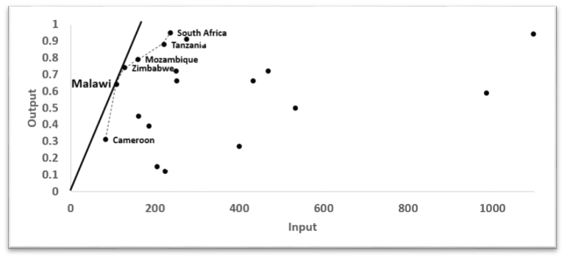

Exhibit : DEA Efficient Frontier: Percentage of Pregnant Women Living with HIV Receiving Antiretroviral Therapy (2014)

Our fourth pairwise DEA analysis includes the input “Total Funding per HIV Positive Adult” and output “Percentage of Children (Aged 0-14 Years) Living with HIV Receiving Antiretroviral Therapy (2014)”. In comparison to the percentage of pregnant women receiving antiretroviral therapy, the percentage of HIV-infected children receiving antiretroviral therapy has been much lower on average. Namibia and Botswana provided treatment to 66% and 53% of the children living with HIV in 2014 respectively, followed closely by South Africa at 49%. However, from an efficiency perspective, Zimbabwe is the benchmark. It achieved 38% with a per-HIV-positive-adult total funding amount of $129. See Exhibit 8.

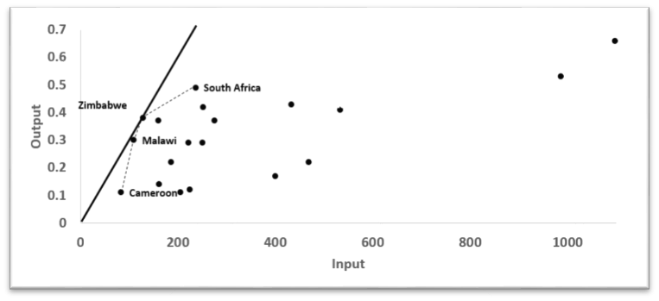

Exhibit : DEA Efficient Frontier: Percentage of Children (Aged 0-14 Years) Living with HIV Receiving Antiretroviral Therapy (2014)

Our fifth pairwise DEA analysis includes the input “Total Funding per HIV Positive Adult” and output “Percentage of Children Exposed to HIV Receiving Co-Trimoxazole (2014)”. Co-Trimoxazole therapy (CPT) prevents pneumonia and other common bacterial infections in children who are exposed to or infected with HIV. A high utilization of this therapy indicates effective HIV testing and treatment in infants and children. Botswana (66%), Mozambique (69%), South Africa (94%), and Swaziland (83%) are the four countries that had more than 50% of HIV-exposed infants and children receiving CPT in 2014. Mozambique achieved such high percentage with a total funding amount per HIV positive adult of $160. It is recognized as the benchmark. See Exhibit 9.

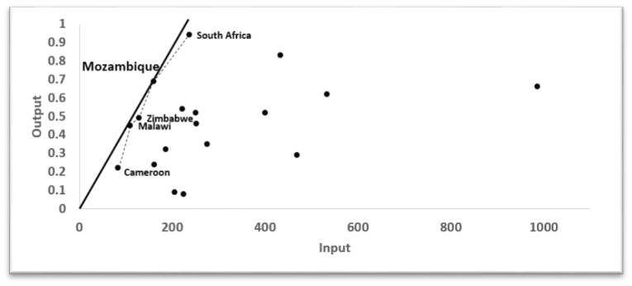

Exhibit : DEA Efficient Frontier: Percentage of Children Exposed to HIV Receiving Co-Trimoxazole (2014)

Our final DEA model includes all the input and output variables discussed above. The outputs were combined using the “Priority Vector” obtained from our AHP analysis. (See Section VII for a detailed explanation.) In essence, it is a DEA model bounded by AHP weights. The results showed that Malawi forms the CRS frontier while South Africa, Zimbabwe, Mozambique, and Cameroon lie on the VRS frontier. Overall, these five countries are more efficient relative to the other sub-Saharan African countries. See Exhibit 10.

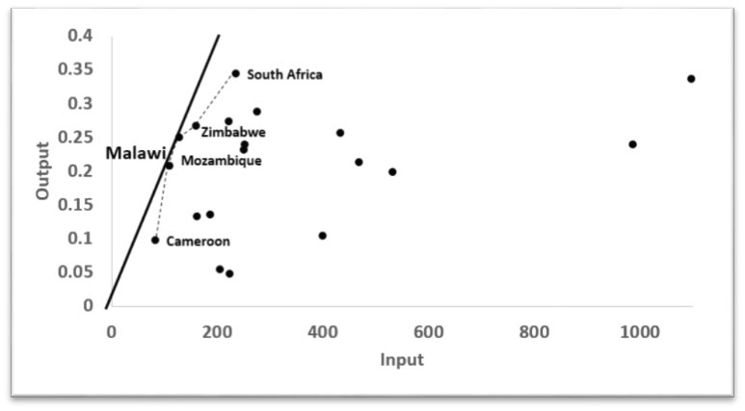

Exhibit : DEA Efficient Frontier: Overall

It is important to note that the DEA efficient frontier method allows an “ethical” display of efficiency assessment. We refrain from “ranking” the countries in a judgmental manner.

* + - 1. **Comparison of AHP and DEA Results**

Let us now re-assess the AHP priority scores vis-à-vis the DEA efficiency scores. As reported earlier, South Africa, Namibia, Uganda, Tanzania, Mozambique, and Swaziland scored the highest in our AHP analysis. Out of these six countries, only four also scored high in the DEA analysis: South Africa, Uganda, Tanzania, and Mozambique. Although Namibia and Swaziland made great strides in reducing new HIV infections, they did so less efficiently. Namibia utilized more than $1,000 in total funding per HIV positive adult to achieve its HIV reduction results.

On the flip side, let us also re-assess the DEA efficiency scores vis-à-vis the AHP priority scores. As reported earlier, Malawi, South Africa, Mozambique, Cameroon, and Zimbabwe are the five countries that formed the efficient frontier in our final DEA run. Four out of the five countries also fared well in the AHP analysis. The exception was Cameroon, which had one of the lowest priority scores. Regardless of its efficient use of funding resources, it did not make as much progress as the other high-efficiency countries in terms of reducing new HIV infections.

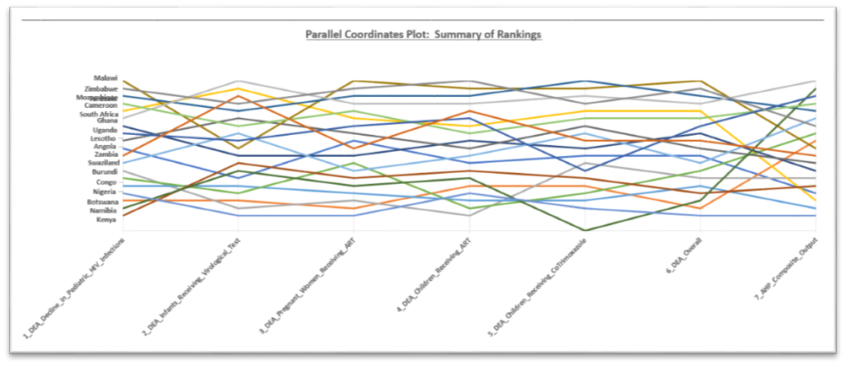

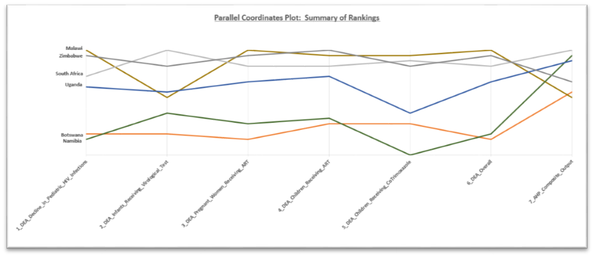

Exhibit : Comparison of AHP and DEA Results

* + - 1. **Linear Regression**

AHP and DEA are strictly benchmarking tools and do not explain the scores and rankings they produce. DEA utilizes an input, i.e. an aggregated amount of funds, and transforms it into a desirable or less desirable output, i.e. a high or low HIV-related performance measure. The transformation process is a black box. We do not know why the desirable or less desirable outputs are produced. In an attempt to open the black box and uncover some of the socioeconomic factors that could have affected the outputs observed, we turned to linear regression.

To obtain the independent variables for regression, we sifted and collected data from numerous data sources. Eventually, we settled on the following 20 variables, most of which were sourced from either the World Bank or the World Health Organization:

* Voice and Accountability World Governance Indicator
* Regulatory Quality World Governance Indicator
* Rule of Law World Governance Indicator
* Control of Corruption World Governance Indicator
* Government Effectiveness World Governance Indicator
* GDP per capita, PPP (current international $)
* Prevalence of underweight, weight for age (% of children under 5)
* Life expectancy at birth, total (years)
* Contraceptive prevalence, any methods (% of women ages 15-49)
* Adult literacy rate, population 15+ years, both sexes (%)
* Population ages 0-14 (% of total)
* Intentional homicides (per 100,000 people)
* Proportion of seats held by women in national parliaments (%)
* Adolescent fertility rate (births per 1,000 women ages 15-19)
* Net Enrolment Ratio of Primary Education
* Gender Parity in Primary Education
* Population Using Improved Drinking Water (%)
* Population Using Improved Sanitation (%)
* Physician Density per 1,000 Population
* Per Capita Government Expenditure on Health (PPP int. $)

We performed our due diligence in cleaning the data and ensuring no multicollinearity among the independent variables. Wherever possible, we transformed the variables into “flow” variables over the time interval between 2009 and 2014. An increase or decrease in measure rather than a point-in-time measure would tell a larger story about the effect on efficiency. See Exhibit 12.

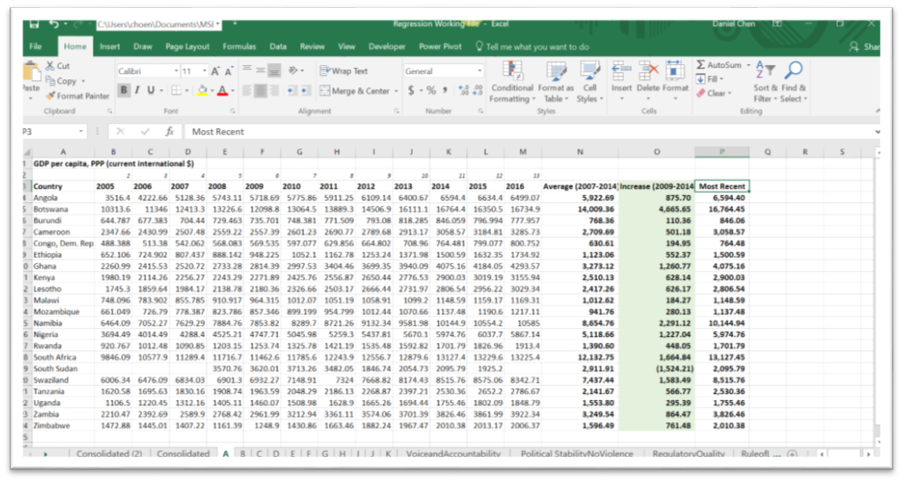

Exhibit : Data Transformation

We conducted two regression runs, each with a set of the 20 independent variables and either the DEA efficiency score or AHP priority score as the response variable. Stepwise regression selected the significant predictors out of these independent variables. The selection cutoffs were set at the α-levels of 0.1 for adding variables to the model and 0.25 for removing variables from the model. The software platform of choice was SAS. See Appendix 3.

The regression with DEA efficiency score as the response produced the following equation (See Appendix 4):

Y = -0.01701 + 0.07859*Incr_Life_Expectancy – 0.00943*Incr_Adolescent_Fertility – 0.76833*Incr_ControlOfCorruptionWGI

All the independent variables are statistically significant at the α-level of 0.1. The equation was not to be used to predict future outcomes, but to identify and explain some of the factors affecting DEA efficiency. The size of the effect the independent variables have on DEA efficiency are described by the coefficients, which can be interpreted as follows:

* On average, holding all other inputs constant, for a one-unit increase in the increase in life expectancy at birth, DEA efficiency increases by 0.08 units. In other words, if life expectancy at birth is increasing, we would expect efficiency to increase; if life expectancy at birth is decreasing, we would expect efficiency to decrease.
* On average, holding all other inputs constant, for a one-unit increase in the increase in teenage fertility rate, DEA efficiency decreases by 0.009 units. In other words, if teenage fertility rate is increasing, we would expect efficiency to decrease; if teenage fertility rate is decreasing, we would expect efficiency to increase.
* On average, holding all other inputs constant, for a one-unit increase in the increase in Control of Corruption World Governance Indicator, DEA efficiency decreases by 0.8 units. In other words, if control of corruption is increasing, we would expect efficiency to decrease; if control of corruption is decreasing, we would expect efficiency to increase.

Life Expectancy at Birth is an indicator of the quality of life and quality of health care. It seems logical that having good medical care in place can enhance the efficiency of combating the HIV epidemic.

Adolescent fertility, also known as teenage fertility, refers to a condition where woman has given live birth before the age of 20 years. It makes sense that teenage fertility rate has an adverse effect on AIDS relief efficiency. A higher prevalence of sexual activity among young girls often leads to more unplanned pregnancies, unsafe abortion, and contracting STIs, which may include HIV/AIDS.

The negative relationship between the increase in corruption control and DEA efficiency is out of line with our expectation. Corruption is detrimental to efficiency. But does a high control-of-corruption indicator mean too much government control that stymies efficiency? If provided the opportunity for further study, we would like to continue to investigate this relationship and look for any possibility of a confounding effect.

The regression with AHP priority score as the response produced the following equation (See Appendix 5):

Y = -0.51846 + 0.00833*HomicidesPer100K + 0.01072*Pct_PrimaryEd

All the independent variables are statistically significant at the α-level of 0.1. Again, the equation was not to be used to predict future outcomes, but to identify and explain some of the factors affecting AHP performance. The coefficients can be interpreted as follows:

* On average, holding all other inputs constant, for a one-unit increase in the number of homicides per 100,000 people, AHP priority score increases by 0.008 units. In other words, if the number of homicides increases, we would expect the priority score to increase; if the number of homicides decreases, we would expect priority to decrease.
* On average, holding all other inputs constant, for a one-unit increase in the percentage of children enrolled in primary school of all primary school-aged children, AHP priority score increases by 0.01 units. In other words, if the net primary school enrollment ratio increases, we would expect the priority score to increase; if the net primary school enrollment ratio decreases, we would expect the priority score to decrease.

It makes sense that the attainability of primary education has a positive effect on the fight against AIDS/HIV. Education is also closely tied to adolescent fertility. When girls have access to education, they are less likely to marry early. Health education is important for promoting health behavior and creating opportunities for prevention.

The positive relationship between the number of homicides and AHP score is out of line with our expectations. Its effect size on the overall regression is very small, however, with a partial eta2 of 0.16. Again, with more time, we would like to investigate further and look for any possibility of confounding effect.

* + - 1. **Hypothesis Testing**

In an effort to gain additional insight into our data, we developed a two-by-two matrix to analyze the same socioeconomic factors as they relate to “low” or “high” DEA and AHP scores. To determine the quadrants, we separated the countries by the mean score for each AHP priority and DEA efficiency. In our code, we encoded the low DEA and high AHP quadrant as quadrant a, and labeled successive quadrants in a clockwise manner. See Exhibit 13.

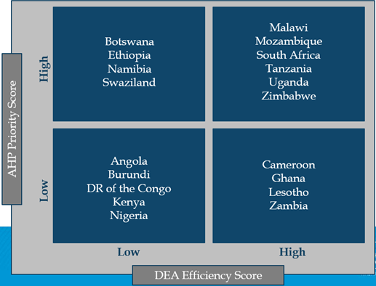

Exhibit : 2x2 Matrix for Hypothesis Testing

We then conducted two separate Student’s t-tests. First, we tested the hypothesis that there was a difference between the mean net primary school enrollment ratios of the low-scoring DEA countries and the high-scoring DEA countries. The p-value of the Folded F test was less than 0.05, so we rejected the null hypothesis that the low- and high-scoring DEA groups had equal variances. Thus, we used the Sattherwaite p-value for our Student’s t-test. Our p-value of 0.1337 lead us to fail to reject the null hypothesis. We were not able to conclude that there was a difference in the mean net primary school enrollment ratios of the low- and high-scoring DEA countries.

Additionally, we performed a Scheffé test to see if there was a difference in the mean net primary school enrollment ratios between the four quadrants. Our Scheffé test produced a p-value of 0.0771, so we failed to reject the null hypothesis that there is no difference between any of the groups. See Appendix 6.

A similar analysis was performed with teenage fertility. Instead of using the variable *increase in teenage fertility*, we instead wanted to know if there was a difference in the most recent teenage fertility measures for the countries in the different quadrants. First, we performed a Student’s t-test to test the hypothesis that there is a difference in the mean teenage fertility rate between the low- and high-scoring AHP countries. Our Folded F p-value was greater than 0.05, so we failed to reject the null hypothesis that the groups had equal variances. Therefore, we used the pooled p-value for our Student’s t-test. Our p-value of 0.7204 is quite large, and therefore we failed to reject the null hypothesis that the two groups have equal mean teenage fertility rates.

Lastly, we performed a Scheffé test to determine if the four quadrants had different mean teenage fertility rates. With a p-value of 0.1670, we failed to reject the null hypothesis that the quadrants have different mean teenage fertility rates. As one can see from the boxplots, it appears that outliers within groups b and c may have influenced this test more strongly. A boxplot excluding outliers seems to imply that there is, in fact, a difference in the mean teenage fertility rates between the quadrants. However, due to small sample sizes, our test did not lead us to accept the alternative hypothesis. See Appendix 7.

* + - 1. **Conclusion**

Sub-Saharan Africa has made tremendous strides in its fight against HIV and AIDS. Since 2005, it has shown declines in new HIV infections by more than 33% overall and AIDS-related deaths by more than 39% overall. However, there is still much work to be done in the region. As of 2015, sub-Saharan Africa is home to only 13% of the global population, yet accounts for 70% of the global burden of HIV infection and more than 70% of global deaths from AIDS-related illnesses.

Through AHP modeling, we identified the strongest-performing countries as they relate to achievement of priority-weighted outputs: South Africa, Namibia, Uganda, Tanzania, Mozambique, and Swaziland.

Through DEA modeling, we highlighted the sub-Saharan countries that have been relatively efficient in utilizing their HIV funding resources to meet the five selected HIV intervention targets. The efficient countries, as identified by DEA, are Malawi, South Africa, Zimbabwe, Mozambique, and Cameroon.

Through stepwise regression, we determined three socioeconomic factors that have had influence over our measurement data: Life Expectancy at Birth, Adolescent Fertility Rate, and Net Enrollment Rate in Primary Education. Although we cannot say that they were the direct causes to the “disparity” in the performances of the countries, we can say with certainty that out of the twenty variables we collected, these are the three most statistically important variables.

In order to improve their performances, this study advises that Angola, Burundi, the Democratic Republic of Congo, Kenya, and Nigeria to work to improve education for young people, which seems to have a direct relationship with better and more cost-effective HIV interventions. Adolescent girls and young women, in particular, may need to have better societal support and access to health information and testing services. A recent NIH study found that the adolescent girls and young women in sub-Saharan Africa acquire HIV infection 5-7 years before men and are the major drivers of new HIV infections.

It is our hope that through this project, we have helped to discover some insights about the current state of HIV relief funding and interventions in sub-Saharan Africa. With additional time and resources, this study could be benefit from further analysis with consistent and complete data and additional measures relating to HIV and AIDS treatment, prevention, education, and socioeconomic conditions.

* + - 1. **References**

(n.d.). Retrieved from The United States President's Emergency Plan for AIDS Relief: http://www.pepfar.gov

*Center for Global Development*. (n.d.). Retrieved from Paper on Benchmarking Supply Chains for Better Performance: https://www.cgdev.org/sites/default/files/CGD-Policy-Paper-57-Iyer-et-al-Benchmarking-Supply-Chains.pdf

Friesner, D., Mujumdar, S., & Cashel-Cordo, P. (2005). Money Well Spent? An Empirical Examination of Government Expenditures for HIV/AIDS Treatment in South Africa. *2005 Proceedings of the Michael Business Economics Association*.

*Funding for HIV and AIDS*. (n.d.). Retrieved from AVERTing HIV and AIDS: https://www.avert.org/professionals/hiv-around-world/global-response/funding

*Global HIV Statistics Fact Sheet 2017.* (n.d.). http://www.unaids.org/sites/default/files/media_asset/UNAIDS_FactSheet_en.pdf

*HIV/AIDS, PEPFAR and the Global Fund*. (n.d.). Retrieved from Interaction - A United Voice for Global Change: https://www.interaction.org/choose-to-invest-2017/hivaids-pepfar-global-fund

Lancheros, J., & Nieto, C. (2015). An Application of the DEA Optimization Methodology to Make More Effective. *SAS Papewr 3371-2015*.

Masiye, F., C, M., & A, E. (2014). Estimating the efficiency of healthcare facilities providing HIV/AIDS treatment in Zambia: a data envelopment approach. In Spinger-Verlag, *International Series in Operations Research & Management Science* (pp. Volume 215: 55-66). Retrieved from http://deazone.com/en/masiye-f-c-mphuka-and-a-emrouznejad-2014-estimating-the-efficiency-of-healthcare-facilities-providing-hivaids-treatment-in-zambia-a-data-envelopment-approach-chapter-4-in-international-seri

*Michael Trick's Operations Research Page*. (n.d.). Retrieved from Quant Classes Notes DEA Chapter 12: http://mat.gsia.cmu.edu/classes/QUANT/NOTES/chap12.pdf

*PEPFAR Impact*. (n.d.). Retrieved from Program Results Achieved Through PEPFAR Support: https://data.pepfar.net/

*Results for Development*. (n.d.). Retrieved from An Exploratory Application of Data Envelopment Analysis to the Efficiency of Health Service Coverage and Access: http://www.resultsfordevelopment.org/knowledge-center/exploratory-application-data-envelopment-analysis-efficiency-health-service-coverag

Shepard, D. S., Zeng, W., Neuman, M. J., Rwiyereka, A. K., & Avila-Figueroa, C. (2007). *Novel and Alternative Approaches to Estimate Global.* Brandeis University, Waltham. Retrieved from http://data.unaids.org/pub/report/2007/20070925_alternative_approaches_estimate_resource_needs_en.pdf

*The Global Fund*. (n.d.). Retrieved from Data Web API: https://www.theglobalfund.org/en/data/

*The World Bank*. (n.d.). Retrieved from World Bank Open Data: http://data.worldbank.org/

*UNAIDS*. (n.d.). Retrieved from UNAIDS Data: http://www.unaids.org/en/dataanalysis

*Wikipedia*. (n.d.). Retrieved from Data Envelopment Analysis: https://en.wikipedia.org/wiki/Data_envelopment_analysis

*World Health Organization*. (n.d.). Retrieved from World Health Organization HIV Data: http://www.who.int/hiv/data/en/

Zeng, W., Rwiyereka, A. K., Amico, P. R., Avila-Figueroa, C., & Shepard, D. S. (2014). Efficiency of HIV/AIDS Health Centers and Effect of Community-Based Health Insurance and Performance-Based Financing on HIV/AIDS Service Delivery in Rwanda. *US National Library of Medicine - National Institutes of Health - PMC*.

Zeng, W., Shepard, D., Avila-Figueroa, C., & Anh, H. (2016). Resource Needs and Gap Analysis in Acheiving Universal Access to HIV/AIDS Services: A Data Envelopment Analysis of 45 Countries. *Pubmed.gov*.

Ayesha B.M. Kharsany and Quarraisha A. Karim. HIV Infection and AIDS in Sub-Saharan Africa: Current Status, Challenges and Opportunities: https://www.ncbi.nlm.nih.gov/pmc/articles/PMC4893541/

* + - 1. **Appendix**

Appendix 1: AHP Modeling in R

# Analytical Hierarchy Process:

# Create "Criteria Comparison Matrix" via FuzzyAHP

comparisonMatrixValues=c(1,9,3,5,9,

1/9,1,1/3,1/3,5,

1/3,3,1,3,7,

1/5,3,1/3,1,8,

1/9,1/5,1/7,1/8,1)

comparisonMatrix=matrix(comparisonMatrixValues, nrow = 5, ncol = 5, byrow = TRUE)

library(FuzzyAHP)

comparisonMatrix=pairwiseComparisonMatrix(comparisonMatrix)

show(comparisonMatrix)

textMatrix=textRepresentation(comparisonMatrix, whole = FALSE)

print(textMatrix)

# Test the consistency of the pairwise comparison matrix

consistencyRatio(comparisonMatrix)

CR = consistencyRatio(comparisonMatrix, print.report = FALSE)

print(CR)

# Calculate the weights of criteria

weights = calculateWeights(comparisonMatrix)

print(weights)

# Calculate the results

values=c(0.25,0.14,0.45,0.14,0.24,

0.58,0.42,0.59,0.53,0.66,

0.57,0.13,0.27,0.17,0.52,

0.27,0.32,0.31,0.11,0.22,

0.27,0.13,0.15,0.11,0.09,

0.65,0.25,0.72,0.22,0.29,

0.51,0.28,0.39,0.22,0.32,

0.29,0.72,0.5,0.41,0.62,

0.42,0.55,0.72,0.29,0.52,

0.53,0.18,0.64,0.3,0.45,

0.69,0.43,0.79,0.37,0.69,

0.64,0.95,0.94,0.66,0,

0.15,0.04,0.12,0.12,0.08,

NA,NA,NA,NA,NA,

0.76,0.94,0.95,0.49,0.94,

NA,NA,NA,NA,NA,

0.63,0.81,0.66,0.43,0.83,

0.72,0.43,0.88,0.29,0.54,

0.69,0.51,0.91,0.37,0.35,

0.38,0.94,0.66,0.42,0.46,

0.57,0.45,0.74,0.38,0.49)

values=matrix(values, nrow=length(values)/length(weights@weights), ncol=length(weights@weights), byrow=TRUE)

result=calculateAHP(weights, values)

rank = compareResults(result)

result = cbind(values, result, rank)

colnames(result) = c("Decline_in_New_HIV_Infections_among_Children", "Infants_Born_to_Women_with_HIV_Receiving_a_Virological_Test", "Pregnant_Women_with_HIV_Receiving_Antiretroviral_Therapy", "Children_with_HIV_Receiving_Antiretroviral_Therapy", "Children_Exposed_to_HIV_Receiving_CoTrimoxazole","Efficiency", "Ranking")

print(result)

Appendix 2: DEA Modeling in R

# Load Input Dataset

require(xlsx)

setwd("C:\\Users\\choen\\Documents\\MSBA_16_17\\SemesterSummer\\DNSC6217_Practicum")

data<-read.xlsx("Practicum_DataFile_06092017.xlsx",1)

# Pairwise A: Select Inputs & Outputs

inputs<-data.frame(data[c(2)]) #Adjust per the number of inputs

outputs<-data.frame(data[c(3)]) #Adjust per the number of outputs

n<-dim(data)[1] #number of decision-making-units(# of rows)

s<-dim(inputs)[2] #number of input variables(# of columns)

m<-dim(outputs)[2] #number of output variables(# of columns)

# Data Envelopment Analysis via Constant-Returns-to-Scale (CRS) Methodology:

# Set up constraints

matrix_rhs<-c(rep(0,1,n),1) #Right-hand sides are 0 for duality constraint and 1 for input weight constraint

matrix_dir<-c(rep("<=",1,n),"=") #"<=" for duality constraint and "=" for input weight constraint

matrix_variables<-cbind(-1*inputs,outputs) #left-hand side of duality constraint

#print(matrix_rhs)

#print(matrix_dir)

#print(matrix_variables)

require(lpSolve)

# Apply DEA

for(i in 1:n){

objective<-c(0*rep(1,s),as.numeric(outputs[i,])) #Weights

#print(objective)

constraint<-rbind(matrix_variables,c(as.numeric(inputs[i,]),rep(0,1,m))) #Outputs & Negative Inputs

#print(constraint)

results<-lp("max",as.numeric(objective),constraint,matrix_dir,matrix_rhs,scale=0,compute.sens=TRUE) #Maximized Weighted Sum of Inputs & Outputs Subject to Constraints

#print(results)

if(i==1){ #Prepare for output

weight<-results$solution

efficiency<-results$objval

lambdas<-results$duals[seq(1,n)]

} else{

weight<-rbind(weight,results$solution)

efficiency<-rbind(efficiency,results$objval)

lambdas<-rbind(lambdas,results$duals[seq(1,n)])

}

}

# Export maximized efficiencies and weights to Excel

spreadsheet<-cbind(efficiency, weight)

rownames(spreadsheet)<-data[,1]

colnames(spreadsheet)<-c("Efficiency",names(inputs),names(outputs))

write.xlsx(spreadsheet,"Practicum_DEAOutputA.xls",col.names=TRUE,sheetName="DEA_Results")

Appendix 3: Stepwise Regressions

/*DEA as the Response*/

/* summarize data */

*proc univariate data=DEA;

*run;

/* stepwise regression */

**proc** **reg** data=DEA_v1;

stepwise: model DEA_Efficiency = Incr_GDPPerCapita -- Pct_Sanitation / selection=stepwise slentry=**0.1** slstay=**0.25**;

**run**;

/* generalized additive model procedure to confirm use of linear regression */

**proc** **glm** data=DEA_v1;

model DEA_Efficiency = Incr_LifeExpectancy Incr_AdolescentFertility Incr_ControlOfCorruptionWGI / effectsize alpha=**0.1**;

**run**;

/* create interaction terms */

**data** DEA_v1;

set DEA_v1;

LifeExpect_AdolescentFertility = Incr_LifeExpectancy * Incr_AdolescentFertility;

LifeExpect_ControlOfCorruption = Incr_LifeExpectancy * Incr_ControlOfCorruptionWGI;

AdolescentFert_ControlOfCorrupt = Incr_AdolescentFertility * Incr_ControlOfCorruptionWGI;

**run**;

/* stepwise regression with interaction terms */

**proc** **reg** data=DEA_v1;

model DEA_Efficiency = Incr_GDPPerCapita -- AdolescentFert_ControlOfCorrupt / selection=stepwise slentry=**0.1** slstay=**0.25**;

*output out=regout p=mhat r=mres;

**run**;

/*AHP as the Response*/

/* summarize data */

*proc univariate data=AHP;

*run;

/* stepwise regression */

**proc** **reg** data=AHP_v1;

model AHP_CompositeScore = Incr_GDPPerCapita -- Pct_Sanitation / selection=stepwise slentry=**0.1** slstay=**0.25**;

**run**;

/* generalized additive model procedure to confirm use of linear regression */

**proc** **glm** data=AHP_v1;

model AHP_CompositeScore = HomicidesPer100k Pct_PrimaryEd / effectsize alpha=**0.1**;

**run**;

/* create interaction terms */

**data** AHP_v1;

set AHP_v1;

Homicides_PrimaryEd = HomicidesPer100k * Pct_PrimaryEd;

**run**;

/* stepwise regression with interaction terms */

**proc** **reg** data=AHP_v1;

model AHP_CompositeScore = HomicidesPer100k -- Homicides_PrimaryEd / selection=stepwise slentry=**0.1** slstay=**0.25**;

*output out=regout p=mhat r=mres;

**run**;

Appendix 4: Regression Result - DEA Efficiency as Response

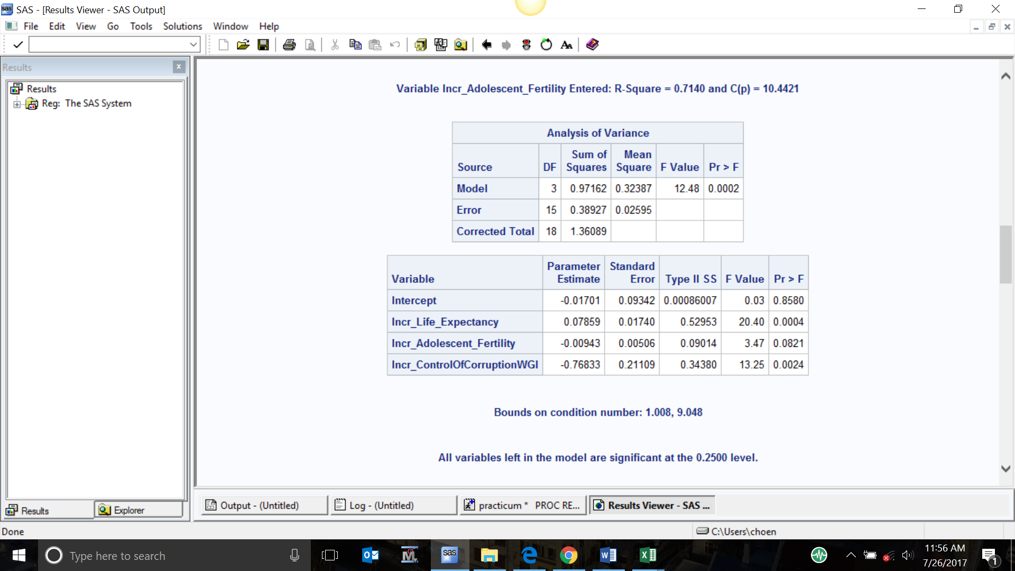

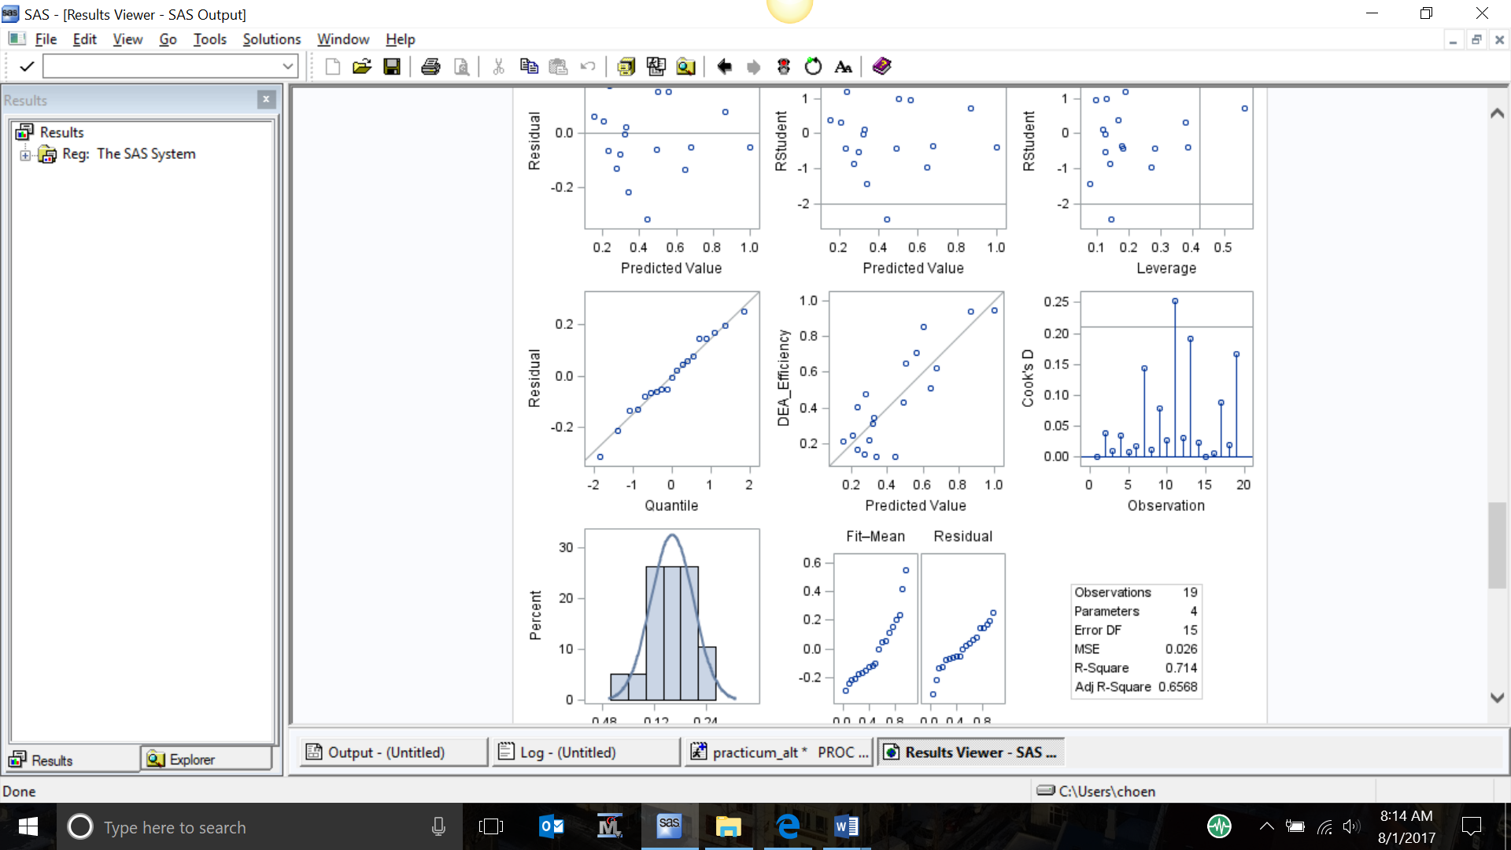

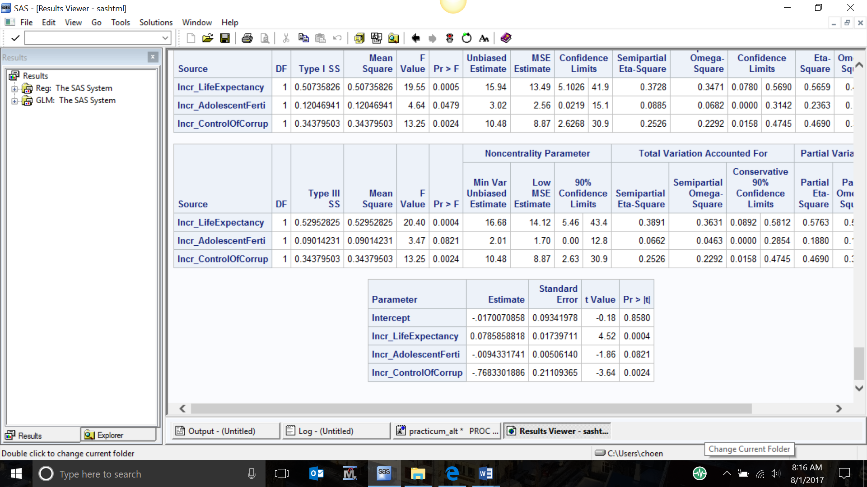

Appendix 5: Regression Result - AHP Priority Score as Response

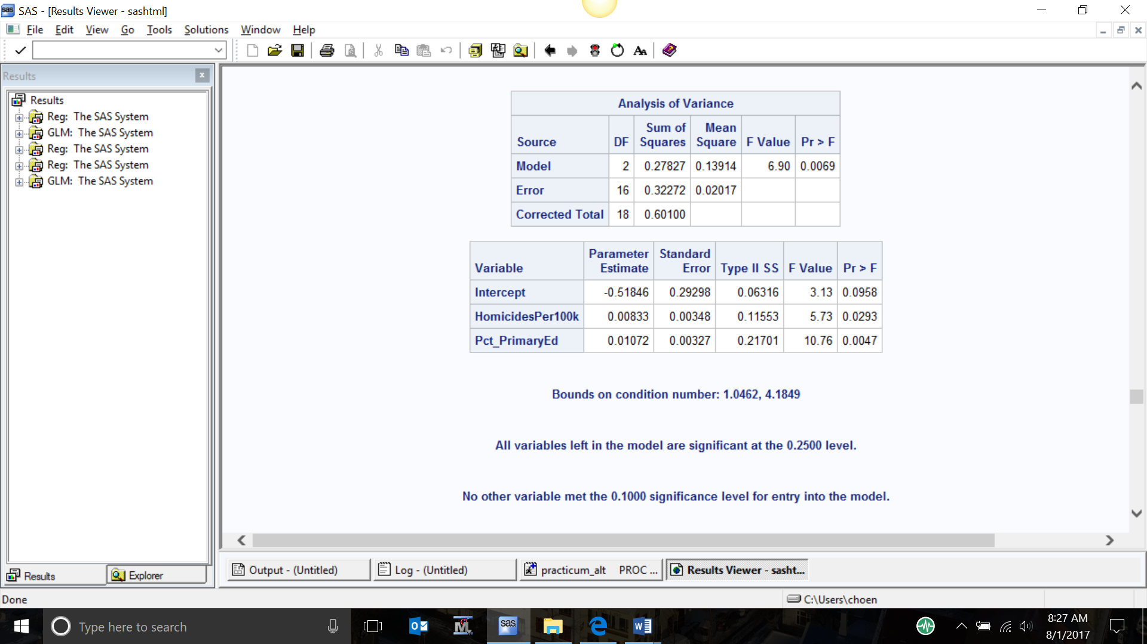

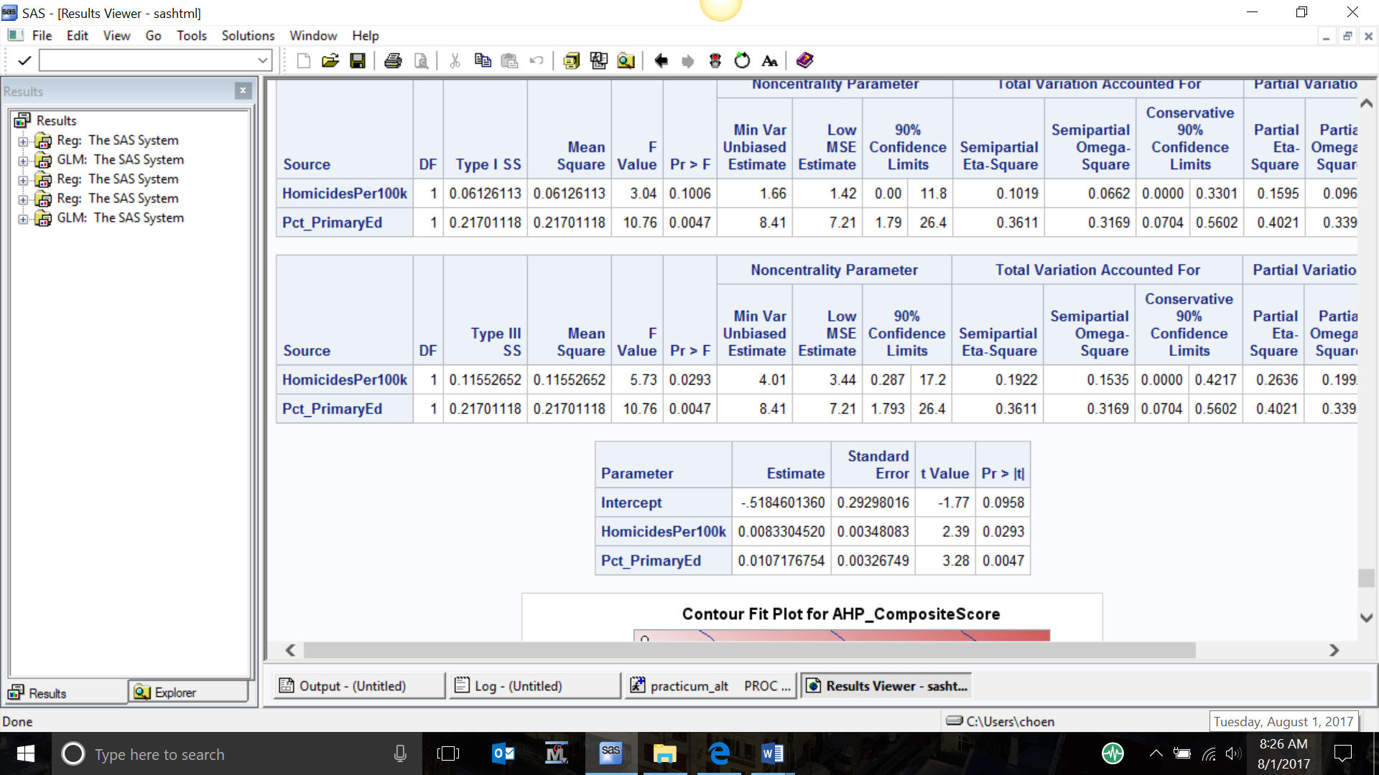

Appendix 6: Net primary school enrollment ratio Student’s t-test and Scheffé test

data quadrants;

input country $ DEAScore DEARank Funding AHPScore AHPRank Primary_Ed Incr_Ad_Fertility Quadrant $ ad_fert DEACat $ AHPCat $;

datalines;

Namibia 0.1425 17 1097.18 0.7186 2 88 -2.3755 a 77.4004 low high

Swaziland 0.3133 12 433.2193 0.6275 6 85 -13.7264 a 73.6144 low high

Ethiopia 0.2492 13 468.4508 0.5675 8 87 -16.8768 a 60.1198 low high

Botswana 0.1256 18 986.6991 0.5658 9 90 -11.4624 a 33.6482 low high

South_Africa 0.7076 4 236.7229 0.7847 1 90 -9.26 b 46.5808 high high

Uganda 0.5109 7 276.0266 0.6746 3 91 -25.7708 b 114.8464 high high

Tanzania 0.6248 6 222.457 0.6714 4 83 -7.9624 b 119.3834 high high

Mozambique 0.8544 3 160.1452 0.6497 5 87 -23.118 b 142.5334 high high

Zimbabwe 0.9417 2 128.8259 0.5723 7 94 -5.4336 b 110.4018 high high

Malawi 0.9454 1 109.928 0.4959 10 98 -12.9648 b 136.972 high high

Zambia 0.4287 9 251.9861 0.4941 11 91 -21.525 c 93.0156 high low

Lesotho 0.4056 10 251.1432 0.4842 12 80 -0.0938 c 92.2794 high low

Ghana 0.4768 8 186.505 0.4196 13 89 -3.1816 c 67.5004 high low

Angola 0.3462 11 161.9767 0.2731 16 86 -16.8172 c 166.6028 high low

Cameroon 0.65 5 83.6934 0.2593 17 95 -17.9152 c 106.853 high low

Congo 0.2118 15 206.2237 0.2045 18 60 -4.8349 d 122.9484 low low

Nigeria 0.1253 19 224.4439 0.1289 19 58 -8.8396 d 111.886 low low

Burundi 0.217 14 399.8822 0.4105 14 95 -3.564 d 28.6552 low low

Kenya 0.1655 16 533.2925 0.396 15 84 -6.2654 d 91.531 low low

;

run;

/* Is there a difference in the primary education ratio between the quadrants?*/

proc sgplot data=quadrants;

vbox primary_ed / category=quadrant;

run;

proc ttest data=quadrants;

var primary_ed;

class AHPCat;

run;

proc glm data=quadrants;

class quadrant;

model primary_ed = quadrant;

means quadrant / scheffe cldiff;

run;

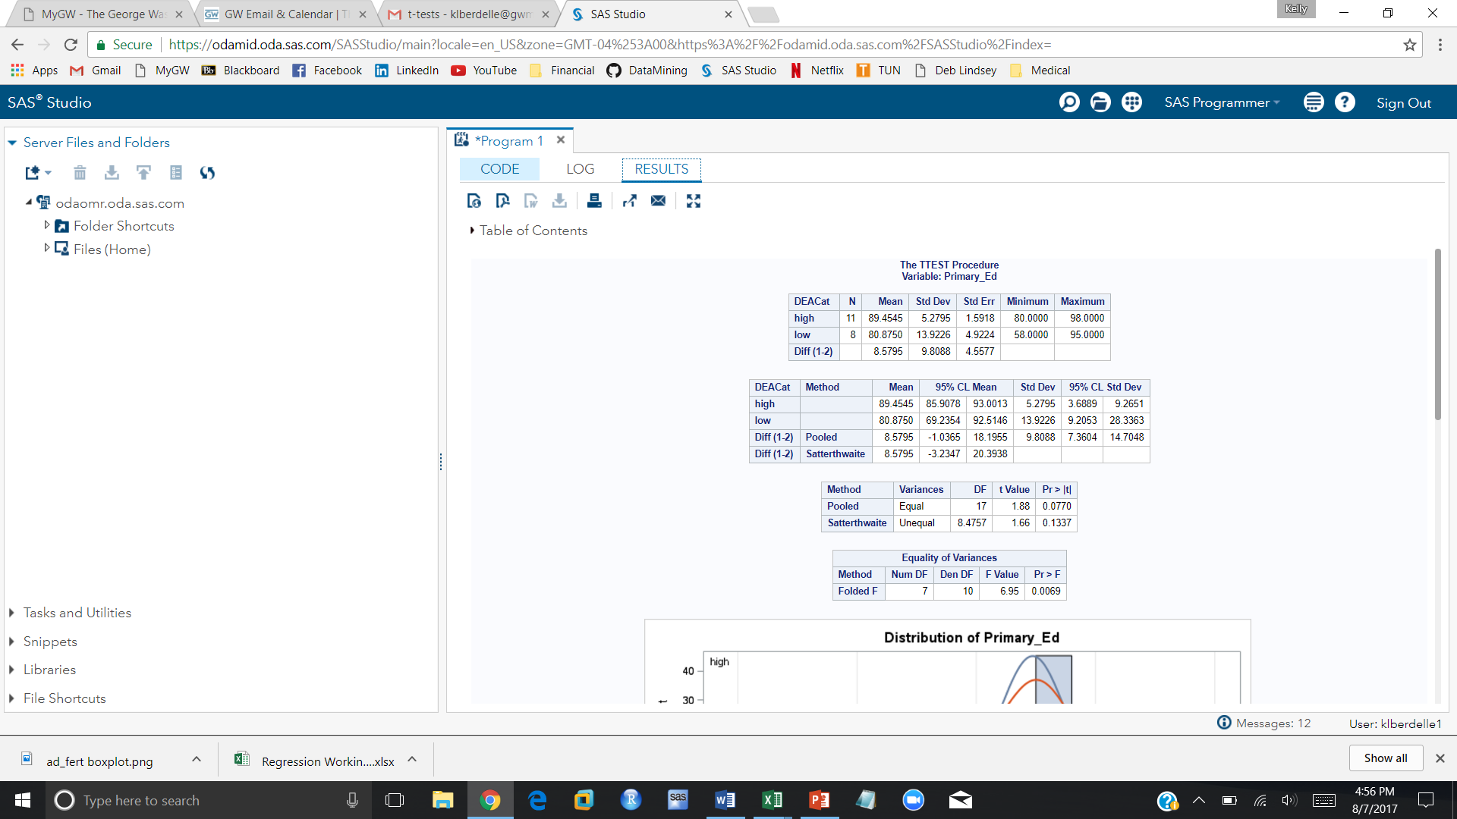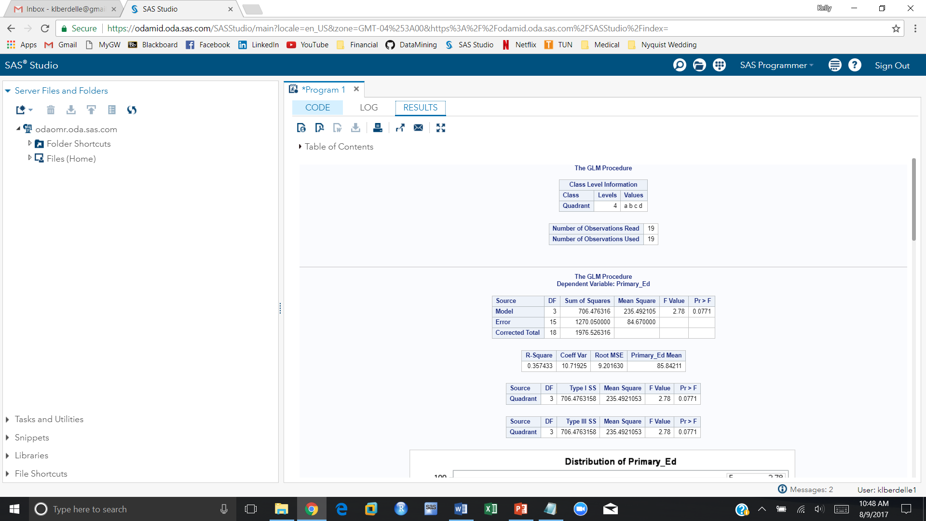

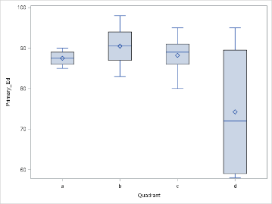

Appendix 7: Teenage fertility rate Student’s t-test and Scheffé test

/* Is there a difference in the teenage fertility rate between the quadrants?*/

proc sgplot data=quadrants;

vbox ad_fert / category=quadrant;

run;

proc ttest data=quadrants;

var ad_fert;

class DEACat;

run;

proc glm data=quadrants;

class quadrant;

model ad_fert = quadrant;

means quadrant / scheffe cldiff;

run;

